**Summary:**

The goal of this assignment was for the student to develop a program that calculates the GPA of the user and determines with the academic standing of the user’s GPA. This was done by first developing pseudocode to get practice on that, and then code the program based on the pseudocode. The program takes in 4 grades, represented numerically, then displays the GPA and the honors. The honors statuses are represented by four boolean variables which are set to TRUE when the GPA satisfies the boolean conditional. One error I ran into was when I included iomanip.h into the file to use “setprecision” to show the grades. I thought that setprecision needed to have a namespace declaration with it, so I ran the code with it and it flagged an error because setprecision does not exist in the library. On a similar note, I frequently ran into fomatting issues (logic errors) using setprecision because this was my first time using that variable; nevertheless, it was a good learning experience using setprecision. The program I developed uses four test cases to test each honors award.

**Test Case 1: Summa Cum Laude**

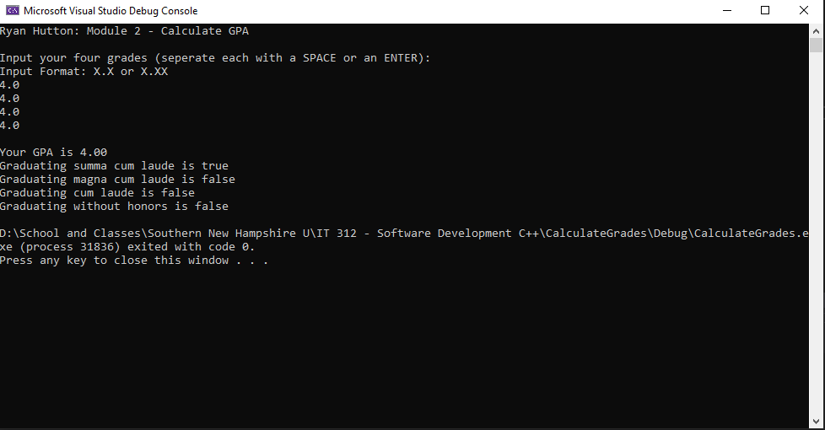

**Test Case 2: Magna Cum Laude**

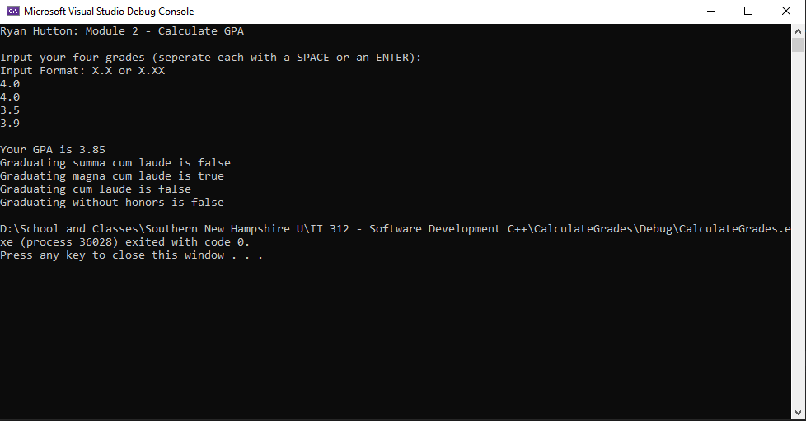

**Test Case 3: Cum Laude**

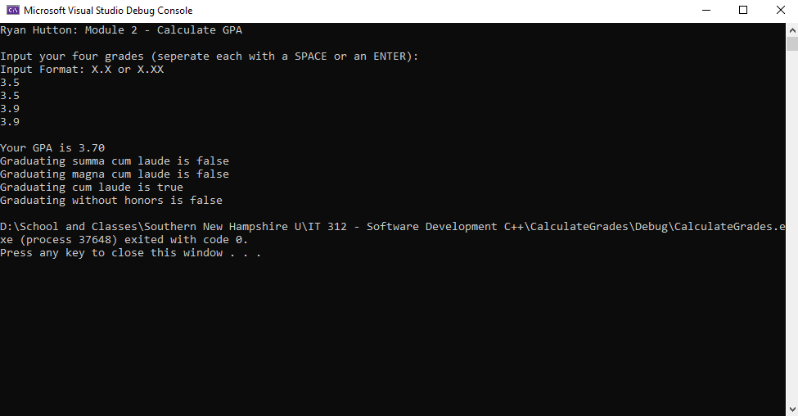

**Test Case 4: No Honors Awarded**

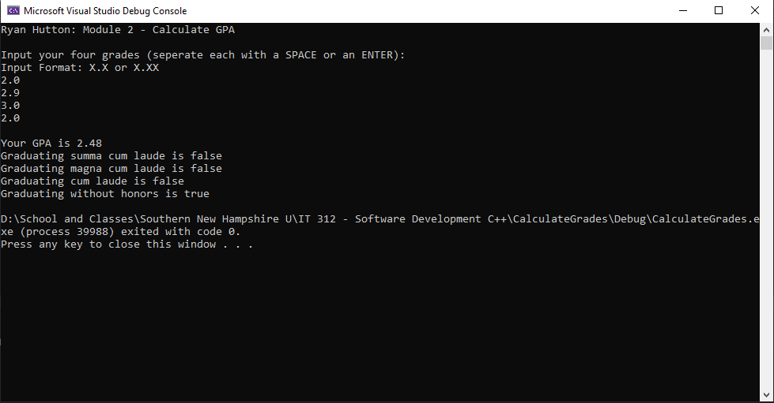

Code on last page.

